Good afternoon sir /Madam.  
  
First of all, thank you for giving me this golden opportunity to introduce myself.  
  
My Name is S. SRI HARISH I am 22 years old.  
  
I am from NAMAKKAL TAMIL NADU.

I did my schooling in THE SPECTRUM ACADEMY, NAMAKKAL and I got 77 per cent in SSLC public exam.

I DID MY INTERMEDIATE IN NARAYANA JR.COLLEGE IN NELLORE, ANDHRA PRADESH, AND I GOT 65 PER CENT IN INTERMEDIATE  
  
I Completed my Graduation in VELLORE INSTITUTE OF TECHNOLOGY, VELLORE AND MY OVERALL CPGA IS 74%   
  
coming to my family background,

There are 3 Members in My Family including me, my mother my father, my sister

My Father is private employee and mother is Homemaker.  
  
My hobbies are PLAYING CRICKET, enjoy nature, designing some components.  
  
my short-term goal is to achieve a job in a reputed company.

What is mechanical design?

Mechanical design is to design parts, components, products, or systems of mechanical nature. For example, designs of various machine elements such as shafts, bearings, clutches, gears, and fasteners fall into the scope of mechanical design.

Why is mechanical design important?

In short, mechanical design services provide the necessary components and framework to achieve the product's intended functions. Many industrial design firms can design the exterior of the product with impressive 3D renderings but, although they can look great, the functional requirements are often not accounted for.

What do you learn in mechanical design?

Through this specialization, you'll learn the foundations of applying computer aided design (CAD), computer aided engineering (CAE), and manufacturing principles while developing your technical skills within Autodesk Fusion 360.

What is tolerance in mechanical engineering drawing?

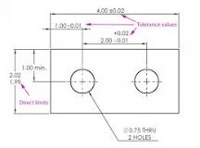

Tolerance is the total amount a dimension may vary and is the difference between the upper (maximum) and lower (minimum) limits. Because it is impossible to make everything to an exact size, tolerances are used on production drawings to control the parts.

These are the five most important skills that every mechanical design engineer should have:

1) Project Management. A mechanical design engineer should be able to develop a project from concept definition to production detail design. ...

2) CAD Software Skills.

3) FEA FINITE ELEMENT ANALYSIS Software Skills. ...

4) PLM Skills. ...

5) Communication Skills.

What are bending stress?

Bending stress is the normal stress that an object encounters when it is subjected to a large load at a particular point that causes the object to bend and become fatigued. Bending stress occurs when operating industrial equipment and in concrete and metallic structures when they are subjected to a tensile load.

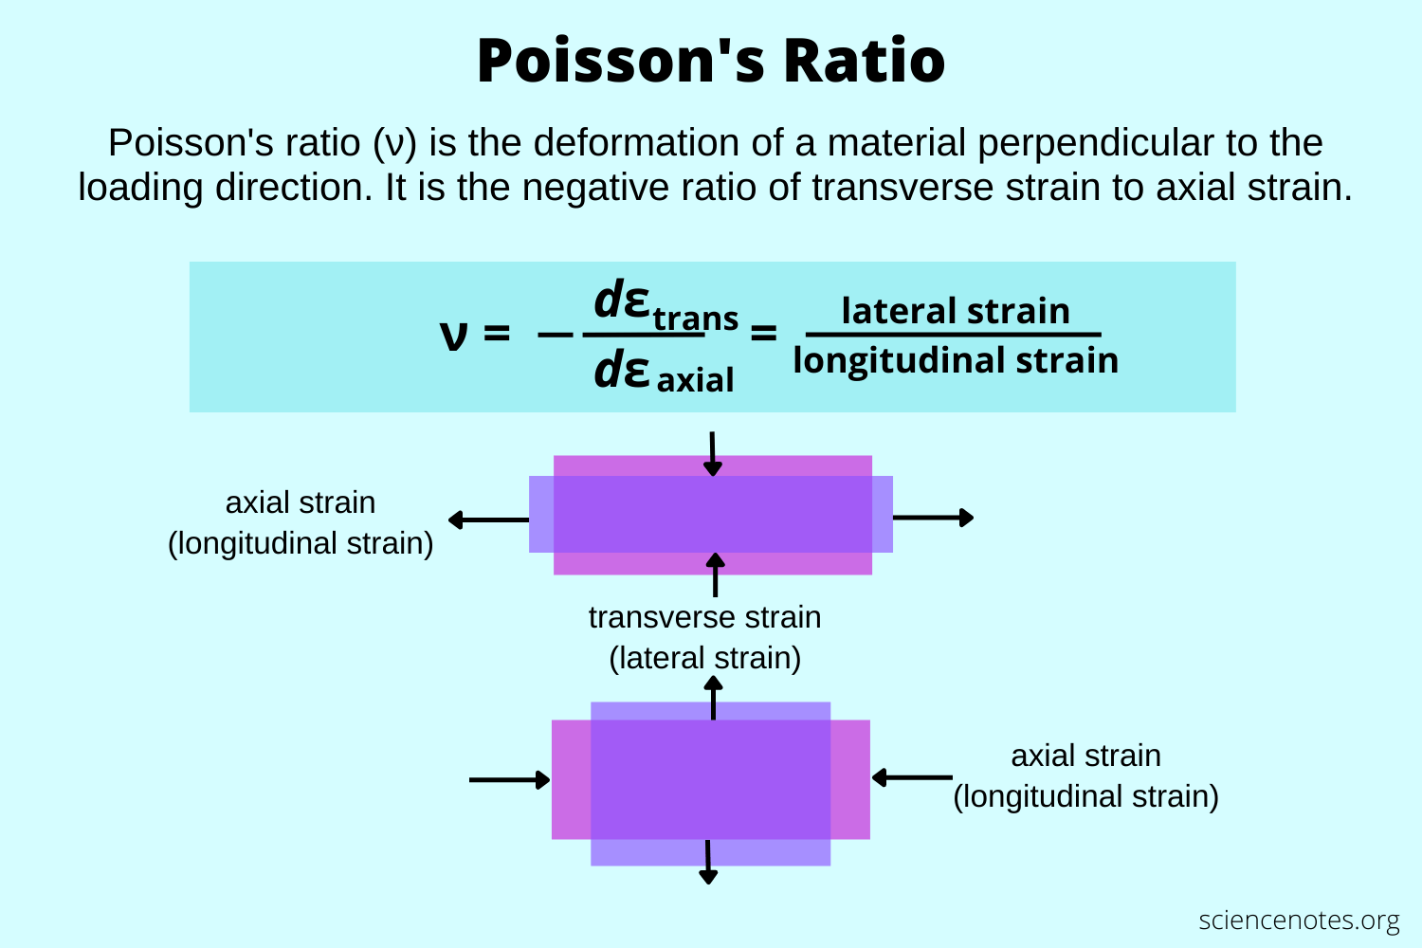

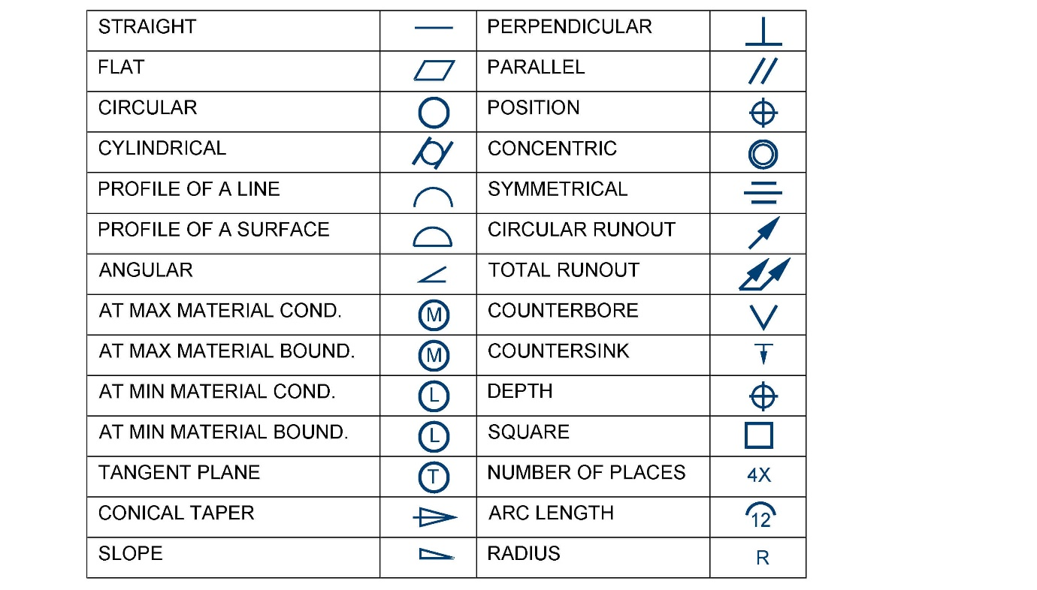

<https://byjus.com/physics/youngs-modulus-elastic-modulus/>

What is weight calculation for steel plates?



What is the formula of weight calculation?

Weight is a measure of the force of gravity pulling down on an object. It depends on the object's mass and the acceleration due to gravity, which is 9.8 m/s2 on Earth. The formula for calculating weight is **F = m × 9.8 m/s2**, where F is the object's weight in Newtons (N) and m is the object's mass in kilograms.

Which material is used in aerospace?



The most commonly used commercial aerospace structural materials are aluminum alloys, titanium alloys, high-strength steels, and composites, generally accounting for more than 90% of the weight of airframes.

<https://www.machinemfg.com/steel-weight-calculation-formula/>

why we need to hire you

I am a versatile person with the ability to deliver results in a constantly changing scenario.i can easily adapt to new plans, stratergize and executive the tasks seamlessly

I went industrial visit in Hyundai manufacturing industry that is on sriprembur Chennai

1st I saw that they are doing one amazing method that is dumping method

In detail they are having die for making the car bodies and panels, by using of that die they are creating the plain panel into a shape of side panel and car body

That die can use for 1300 panels

And then they moved us to next section of assembly

That is the thing I learn from that IV.

And they assemble 150 finished cars in one day.